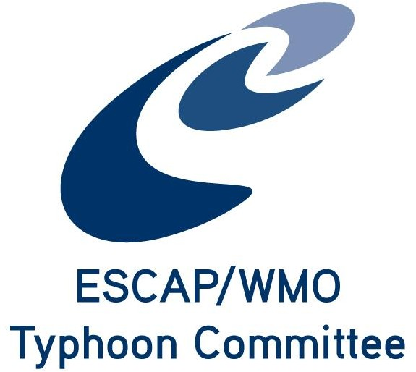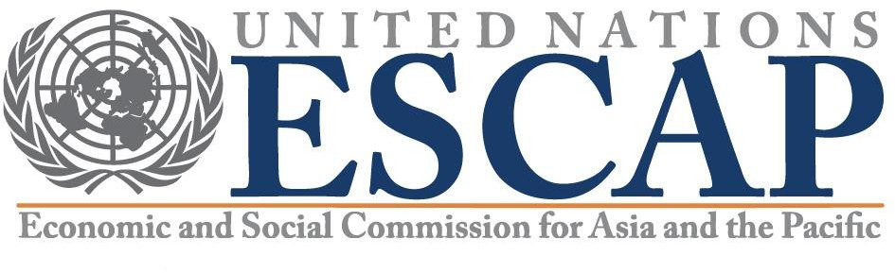

Tentative programme of WGDRR Parallel Meeting
In the Typhoon Committee 16th Integrated Workshop (IWS)
From 02 to 03 December 2021 Virtual meeting

The Parallel Session of TC Working Group will be held on 02 December, the day 1 afternoon of 16th IWS Convener: WGDRR Vice Chair Dr. Yuntae Kim (NDMI)
DAY 1 aftenoon of 16th IWS TUESDAY, 02 December 2022
14:00-17:00 (HK time) Parallel Session - WGM, WGH, WGDRR presentations of Members Report
WGDRR Programme:
14:00 - 14:15 Opening and participants introduction
14:15 - 15:15 Member Reports and discussion
15:15 – 16:30 Brief review of projects and report the decision for the proposal for project plan in 2022 by the WGDRR virtual meeting that was held on 5 Nov 2021
- Summary of AOPs 2021 implementation status and AOPs Plan for 2022
- Review of TCTF budget allocation in 2021 and request for 2022
- Discussion and decision for the WGDRR Reports with conclusions and recommendations to the TC 54th Session
- Other issues
Members are expected to submit the presentations and summary of the country report of DRR component (PPT file and word version) to proxy for NDMI Dr. Chihun Lee (chihun@korea.kr) , and Ms. Eunji Seo(ejseo928@korea.kr) with copy to TCS (michael@typhooncommittee.org, info@typhooncommittee.org), before or on 25 Nov 2021.
- Malaysia
- Philippines
- Republic of Korea
- Singapore
- Thailand
- the United States
- Vietnam
- Cambodia
- China
- DPRK
- Hong Kong, China
- Japan
- Laos
- Macao, China

1

